Test Cases (FRONT END)

1. Input Validation

Test Cases:

* 1. Scenario: When the user enters a non-numeric value (e.g., "A", "B").

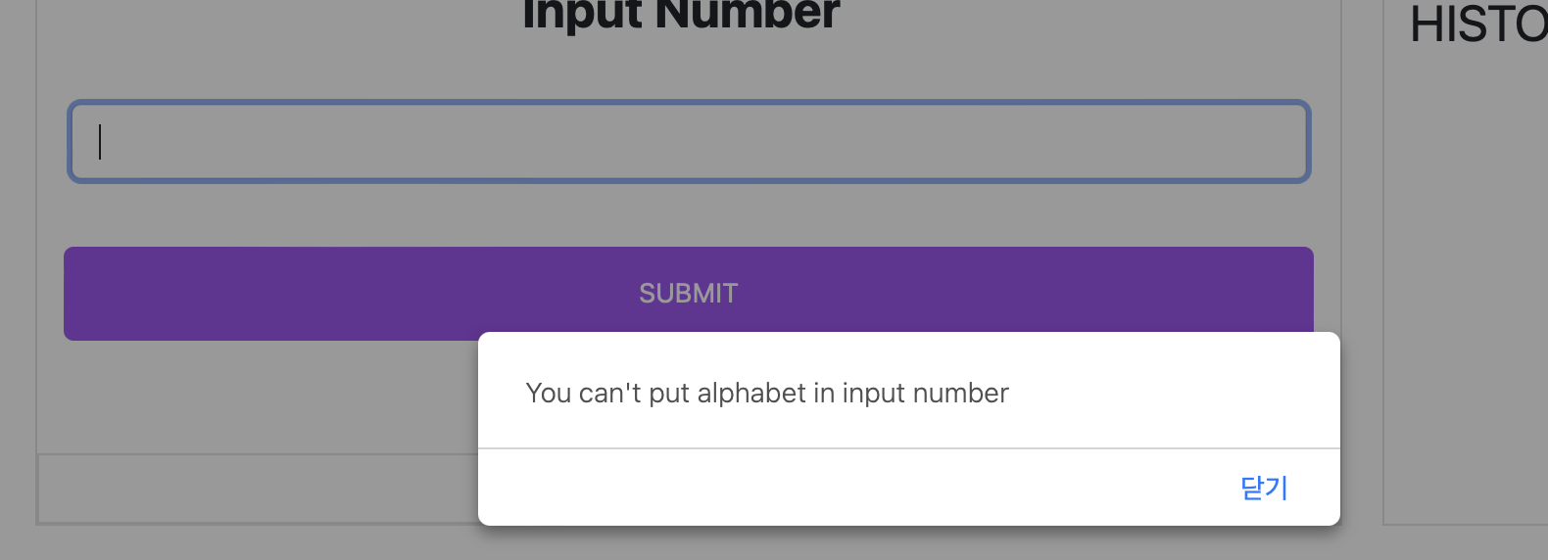

* 1. Scenario: When the user enters special characters (e.g., "@", "#", "$").

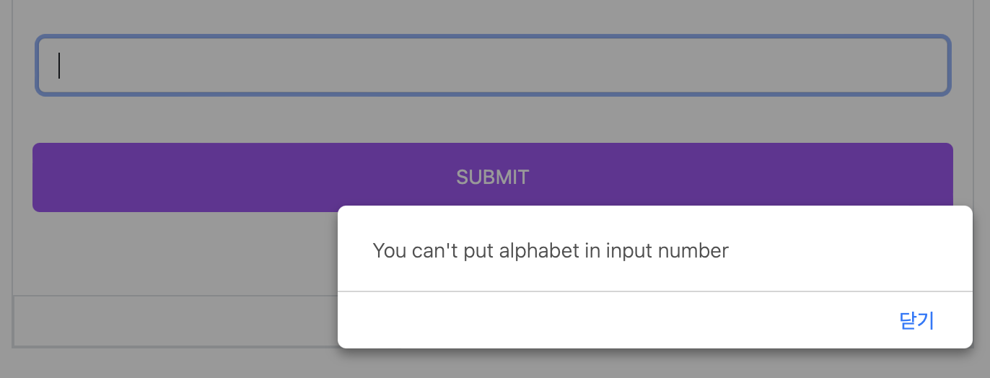

* 1. Scenario: When the user enters a number with multiple decimal points (e.g., "123.45.67").

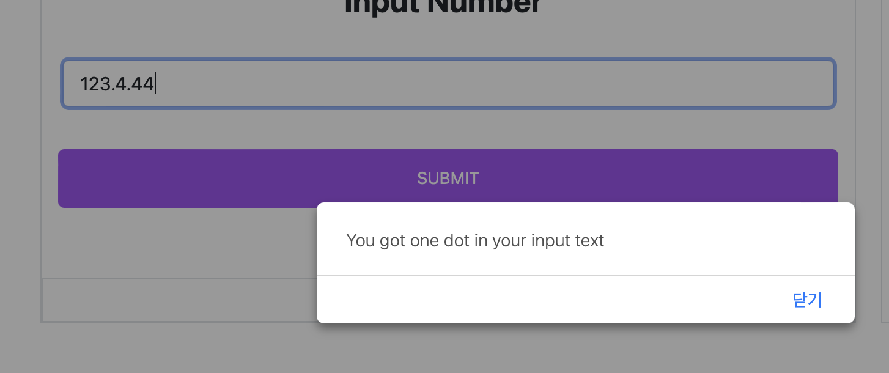

* 1. Scenario: When the user enters a number with more than 3 decimal places (e.g., "123.456").

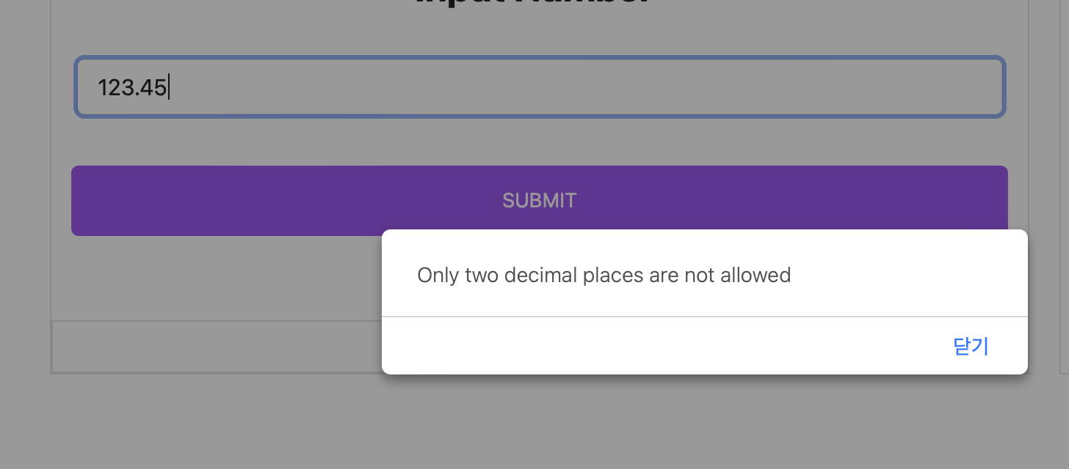

* 1. Scenario: When the user enters a number with leading zeros (e.g., "00123.45").

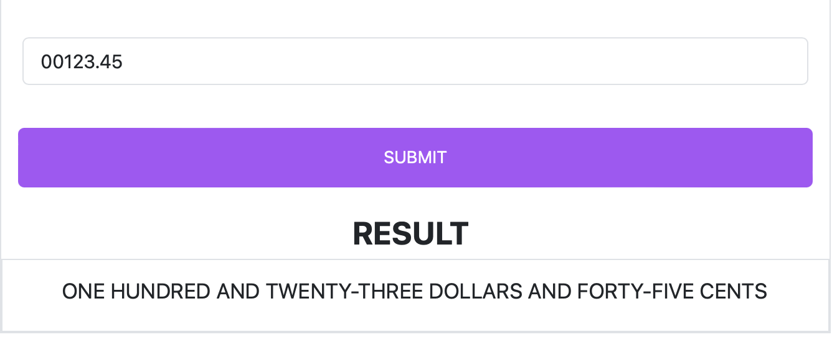

* 1. Scenario: When the user enters a dot as the last character (e.g., "123.").

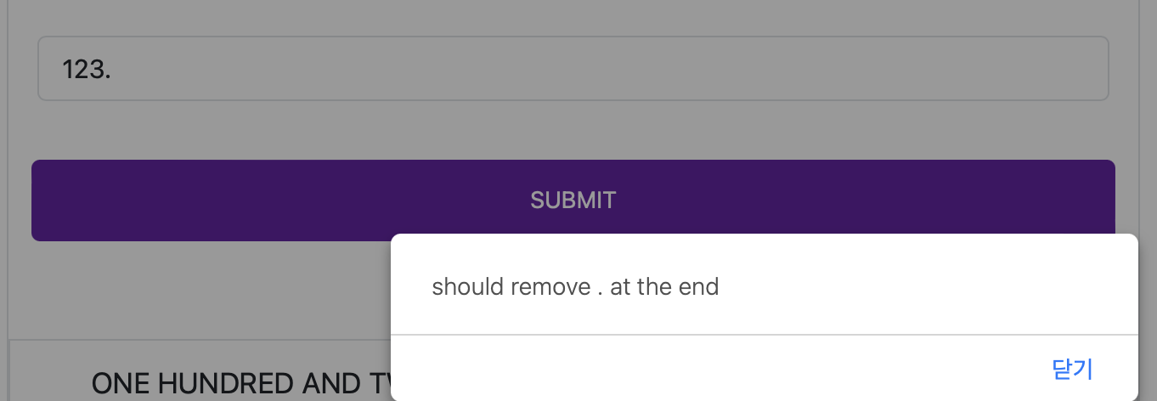

* 1. Scenario: When the user enters an empty value (e.g., "").

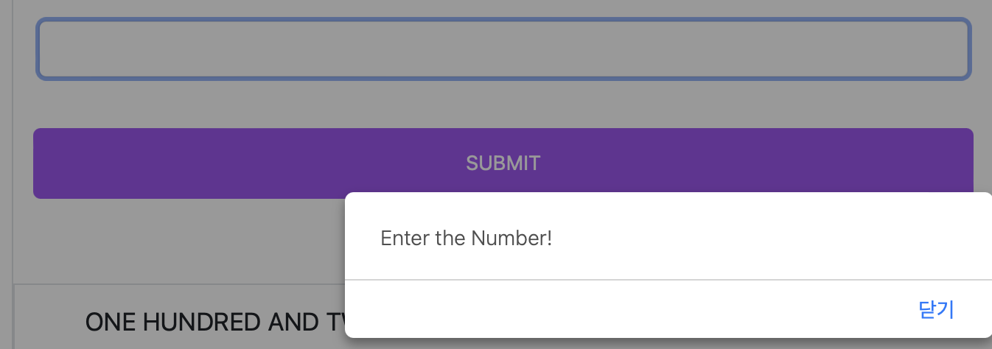

* 1. Scenario: When the user pastes an invalid value.

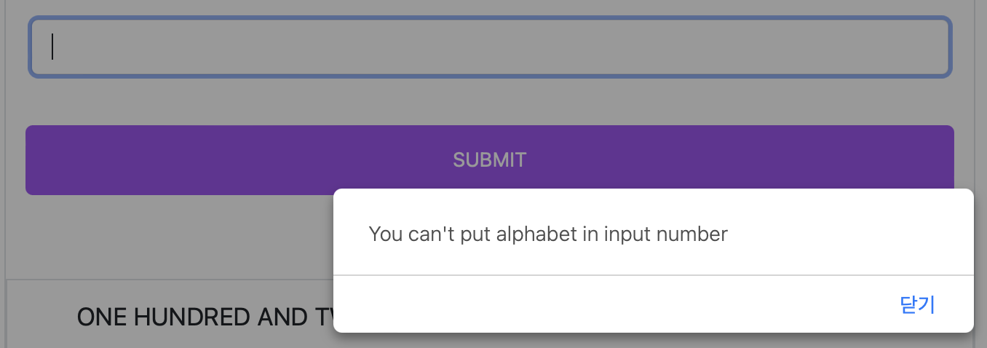

Expected Behavior:

1. The system should validate and sanitize the input.

2. The submit button will be disabled or a warning message will be shown.

2. Range Limits:

Test Cases:

2.1 Scenario: When the user enters an extremely large number (more than 30 digits).

2.2 Scenario: When the user enters a very small decimal number (e.g., "0.01").

2.3 Scenario: When the user enters zero.

2.4 Scenario: When the user enters negative numbers.

Expected Behavior:

For scenario 2.1, the system should return a warning message.

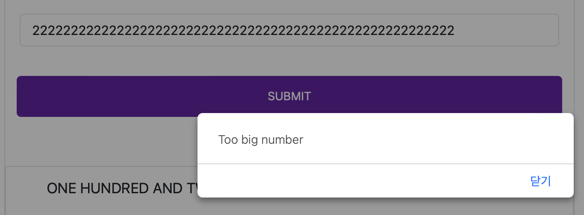

For scenario 2.2, the system should return "ZERO DOLLARS AND ONE CENT."

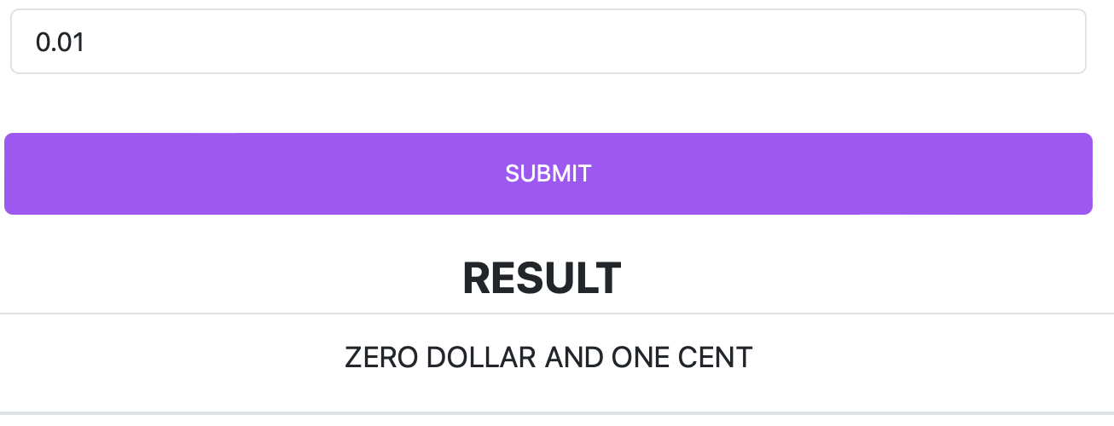

For scenario 2.3, the system should return a warning message.

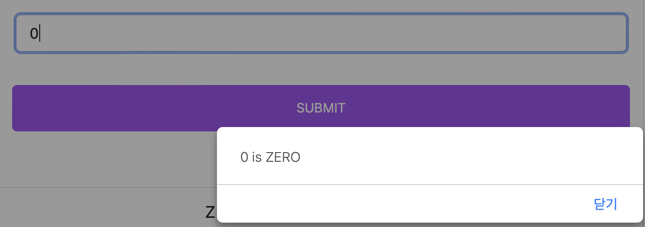

For scenario 2.4, the system should return "You can't input letters as the number" because negative numbers are not allowed.

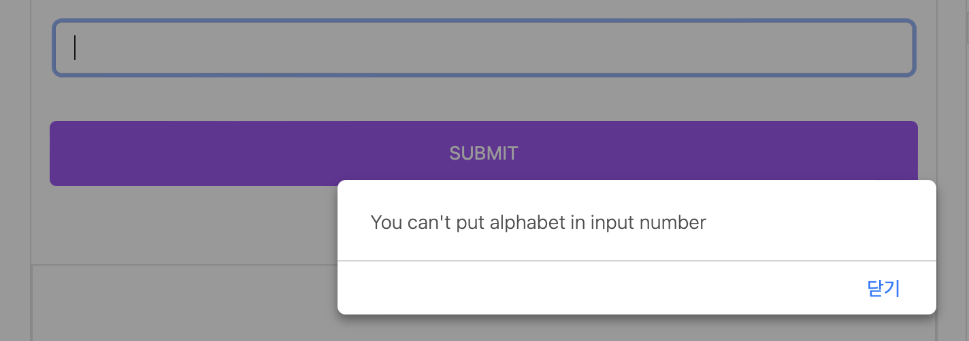

3. Output Format:

Test Cases:

3.1 Scenario: When the input is a decimal number without a whole number part (e.g., ".45").

3.2 Scenario: When the input is a decimal number without a decimal part (e.g., "123.").

Expected Behavior:

For scenario 3.1, the system should return "should remove the dot at the start."

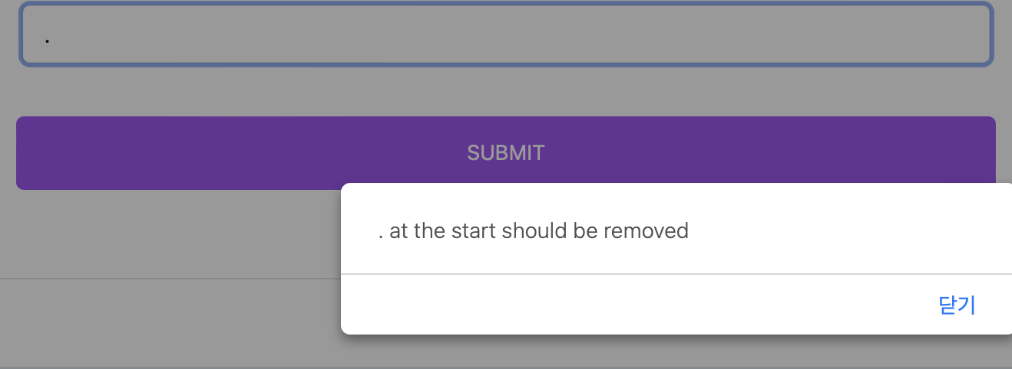

For scenario 3.2, the system should return "should remove the dot at the end."

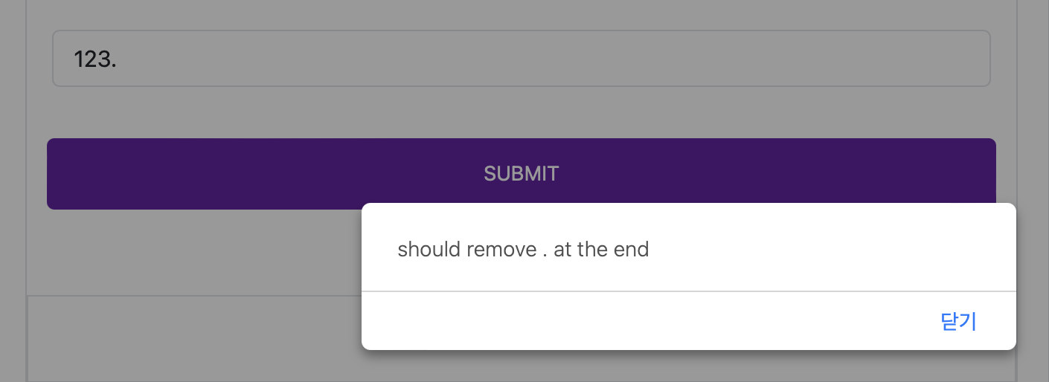

4. Edge Cases:

Test Cases:

4.1 Scenario: When the input consists of only decimal places without any significant digits (e.g., "0.00").

Expected Behavior:

For scenario 4.1, the system should return "ZERO DOLLARS."

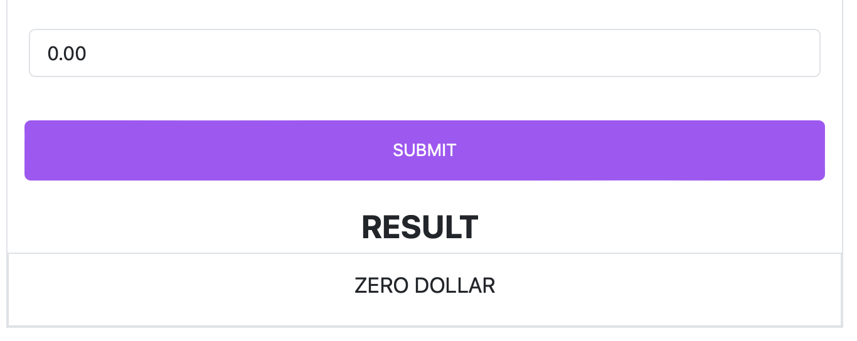

5. Usability:

Test Cases:

5.1 Scenario: Ensure the input box is easily identifiable.

5.2 Scenario: Ensure there's a clear call to action (e.g., a "SUBMIT" button).

5.3 Scenario: Ensure error messages are clear and helpful.

6. History:

Test Cases:

6.1 Scenario: After submitting valid input, ensure the input appears in the history field.

6.2 Scenario: After multiple valid inputs, ensure all are recorded in the history field in the correct order.

6.3 Scenario: Submitting invalid input should not be added to the history field.

7. Click History:

Test Cases:

7.1 Scenario: Click on an entry in the history field. The clicked entry should populate the input field.

7.2 Scenario: After populating the input field from history, clicking submit should display the same result as shown in the history.

8. Clear Button:

Test Cases:

8.1 Scenario: Click the clear button when the history is populated. The history field should be cleared.

8.2 Scenario: Click the clear button when the history is empty. Nothing should happen.

8.3 Scenario: After clearing history, enter and submit a valid number. The number should appear in the history, and previously cleared entries should not reappear.

9. Responsive Design:

Test Cases:

9.1. Test on different browsers (Chrome, Firefox, Safari) to ensure cross-browser compatibility.